Pass for level 15: AwWj0w5cvxrZiONgZ9J5stNVkmxdk39J

Step 1:Login to natas 14

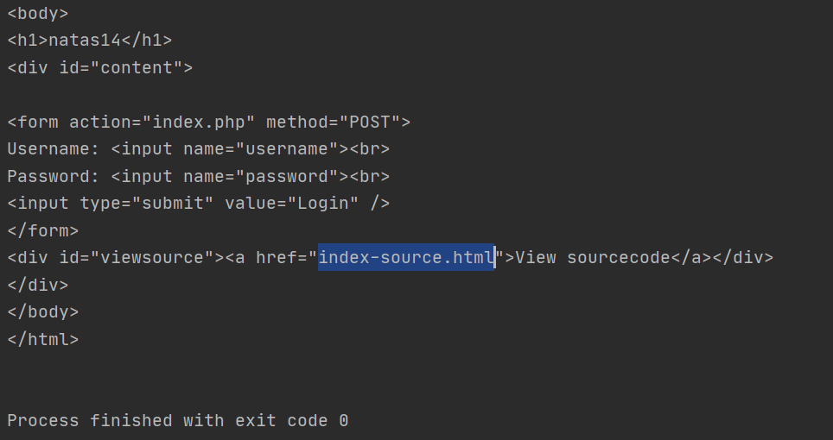

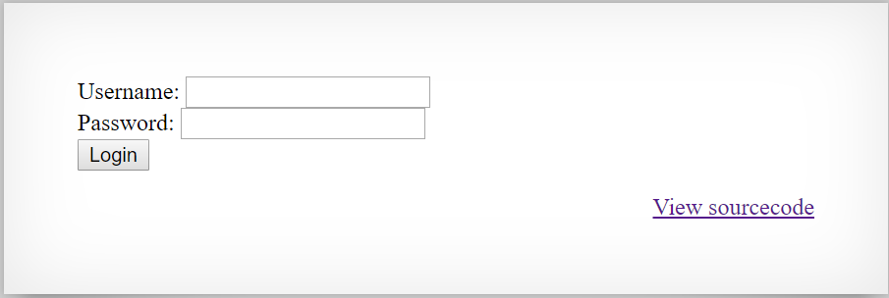

Step 2: View source code

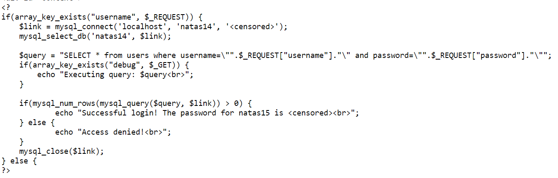PHP code that use sql query for username and password .

Probably I need to use SQL injection attack.

So I entered true statement in the username and password.

Step 3:Login via post requests in python with extension **?debug=true** to see the results

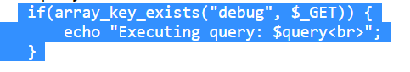

Using my Level14.py program.

